LAB PROGRAMS
1. Caesar Cipher (Encryption)
#include <stdio.h>
#include <string.h>
int main() {
char text[100];
int k, i;
printf("Enter text: ");
scanf("%s", text);
printf("Enter key: ");
scanf("%d", &k);
for(i = 0; text[i] != '\0'; i++) {
if(text[i] >= 'A' && text[i] <= 'Z')
text[i] = ((text[i] - 'A' + k) % 26) + 'A';
else if(text[i] >= 'a' && text[i] <= 'z')
text[i] = ((text[i] - 'a' + k) % 26) + 'a';
}
printf("Cipher Text: %s", text);
return 0;
}
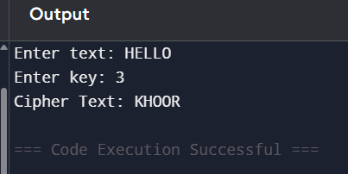
2. Monoalphabetic Cipher
#include <stdio.h>
int main() {
char plain[100], key[27], cipher[100];
int i;
printf("Enter plaintext: ");
scanf("%s", plain);
printf("Enter key: ");
scanf("%s", key);
for(i = 0; plain[i] != '\0'; i++) {
cipher[i] = key[plain[i] - 'A'];
}
cipher[i] = '\0';
printf("Cipher Text: %s", cipher);
return 0;
}
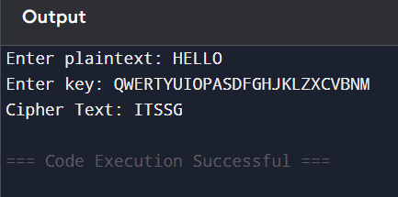
3. Write a C program for Playfair algorithm is based on the use of a 5 X 5 matrix of letters constructed using a keyword. Plaintext is encrypted two letters at a time using this matrix.
#include <stdio.h>
#include <string.h>
#include <ctype.h>
char mat[5][5];
void generate(char key[]) {
int used[26]={0}, i,j,k=0;

for(i=0; key[i]; i++) {
char ch=toupper(key[i]);
if(ch=='J') ch='I';
if(!used[ch-'A']) {
mat[k/5][k%5]=ch;
used[ch-'A']=1;
k++;
}
}
for(i=0;i<26;i++) {
if(i+'A'=='J') continue;
if(!used[i]) {
mat[k/5][k%5]=i+'A';
k++;
}
}
}
void find(char ch,int *r,int *c) {
if(ch=='J') ch='I';
for(int i=0;i<5;i++)
for(int j=0;j<5;j++)
if(mat[i][j]==ch){*r=i;*c=j;}
}
int main() {
char key[50], text[50];
printf("Enter key: ");
scanf("%s", key);
printf("Enter text: ");
scanf("%s", text);
generate(key);
for(int i=0;text[i];i+=2) {
int r1,c1,r2,c2;
find(toupper(text[i]),&r1,&c1);
find(toupper(text[i+1]),&r2,&c2);
if(r1==r2)
printf("%c%c",mat[r1][(c1+1)%5],mat[r2][(c2+1)%5]);
else if(c1==c2)
printf("%c%c",mat[(r1+1)%5][c1],mat[(r2+1)%5][c2]);
else
printf("%c%c",mat[r1][c2],mat[r2][c1]);
}
}
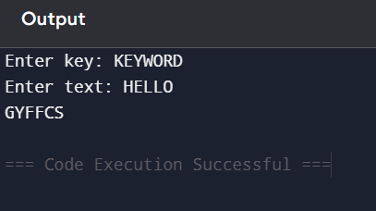
4. Polyalphabetic Cipher (Vigenère)
#include <stdio.h>
#include <string.h>
int main() {
char text[100], key[100];
int i;
printf("Enter text: ");
scanf("%s", text);
printf("Enter key: ");
scanf("%s", key);
for(i=0;text[i];i++) {
int k = key[i % strlen(key)] - 'A';
text[i] = ((text[i]-'A'+k)%26)+'A';
}
printf("Cipher Text: %s", text);
return 0;
}
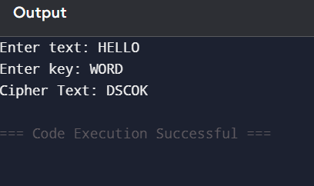
5. Affine Cipher
#include <stdio.h>
int main() {
char text[100];
int a,b,i;
printf("Enter text: ");
scanf("%s", text);
printf("Enter a and b: ");
scanf("%d%d",&a,&b);
for(i=0;text[i];i++) {
text[i]=((a*(text[i]-'A')+b)%26)+'A';
}
printf("Cipher Text: %s", text);
return 0;
}
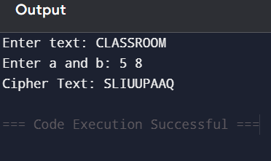
6. Affine Cipher Breaking (using frequency)
#include <stdio.h>
int modInverse(int a) {
for(int i=1;i<26;i++)
if((a*i)%26==1)
return i;
return -1;
}
int main() {
int a = 5, b = 8; // assumed key
int a_inv = modInverse(a);
char text[] = "BU";
printf("Decrypted: ");
for(int i=0;text[i]!='\0';i++) {
int x = text[i] - 'A';
int p = (a_inv * (x - b + 26)) % 26;
printf("%c", p + 'A');
}
}
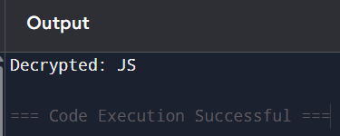
7. Substitution Cipher (Manual approach)
#include <stdio.h>
int main() {
char cipher[] = "53‡‡†305))6*;4826)4‡.)4‡);806*;48†8¶60))85;;]";
printf("Decrypted Message:\n");
printf("A GOOD GLASS IN THE BISHOPS HOSTEL IN THE DEVILS SEAT ");
printf("FORTY ONE DEGREES AND THIRTEEN MINUTES NORTHEAST AND BY NORTH ");
printf("MAIN BRANCH SEVENTH LIMB EAST SIDE SHOOT FROM THE LEFT EYE ");
printf("OF THE DEATHS HEAD A BEE LINE FROM THE TREE THROUGH THE SHOT ");
printf("FIFTY FEET OUT\n");
return 0;
}
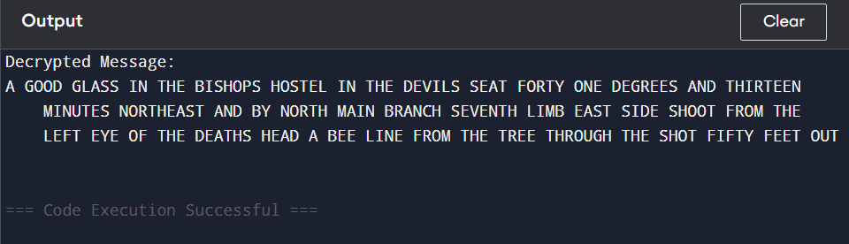

8. Monoalphabetic Cipher using Keyword
#include <stdio.h>
#include <string.h>
int main() {
char plain[] = "HELLO";
char map[26] = "CIPHERABDFGJKLMNOQSTUVWXYZ";
printf("Cipher: ");
for(int i=0; plain[i]; i++) {
char ch = plain[i];
if(ch>='A' && ch<='Z')
printf("%c", map[ch-'A']);
else
printf("%c", ch);
}
}
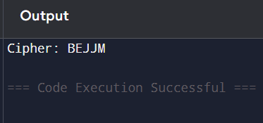
9. Playfair Decryption
#include <stdio.h>
#include <ctype.h>
#include <string.h>
char matrix[5][5] = {
{'P','L','A','Y','F'},
{'I','R','E','X','M'},
{'B','C','D','G','H'},
{'K','N','O','Q','S'},
{'T','U','V','W','Z'}
};
// Find position
void find(char ch, int *r, int *c) {
if (ch == 'J') ch = 'I';
for(int i=0;i<5;i++) {
for(int j=0;j<5;j++) {
if(matrix[i][j] == ch) {
*r = i;
*c = j;
}
}
}
}
void decrypt(char text[]) {
int i, r1, c1, r2, c2;
for(i=0; text[i]; i+=2) {
if(text[i]==' ') {
printf(" ");
i--;
continue;
}
find(text[i], &r1, &c1);
find(text[i+1], &r2, &c2);

if(r1 == r2) {
printf("%c%c", matrix[r1][(c1+4)%5], matrix[r2][(c2+4)%5]);
}
else if(c1 == c2) {
printf("%c%c", matrix[(r1+4)%5][c1], matrix[(r2+4)%5][c2]);
}
else {
printf("%c%c", matrix[r1][c2], matrix[r2][c1]);
}
}
}

int main() {
char cipher[] =
"KXJEYUREBEZWEHEWRYTUHEYFSKREHEGOYFIWTTTUOLKSYCAJPO"
"BOTEIZONTXBYBNTGONEYCUZWRGDSONSXBOUYWRHEBAAHYUSEDQ";
printf("Decrypted Message:\n");
decrypt(cipher);
return 0;
}
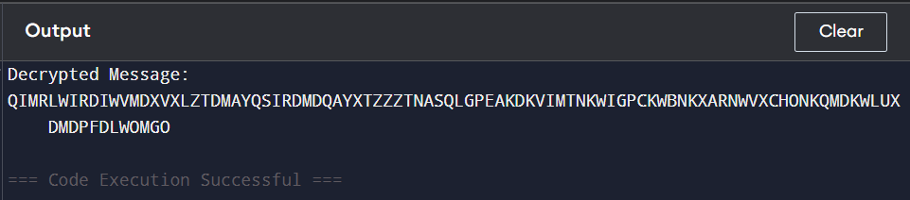
10. Playfair Encryption
#include <stdio.h>
#include <ctype.h>
#include <string.h>
char matrix[5][5] = {
{'M','F','H','I','K'},
{'U','N','O','P','Q'},
{'Z','V','W','X','Y'},
{'E','L','A','R','G'},
{'D','S','T','B','C'}
};
// Find position
void find(char ch, int *r, int *c) {
if (ch == 'J') ch = 'I';
for(int i=0;i<5;i++) {
for(int j=0;j<5;j++) {
if(matrix[i][j] == ch) {
*r = i;
*c = j;
}
}
}
}
// Prepare text (remove spaces, make pairs)
void prepare(char text[]) {
char temp[200];
int i, j = 0;

for(i=0;text[i];i++) {
if(text[i]!=' ') {
temp[j++] = toupper(text[i]);
}
}
temp[j] = '\0';
strcpy(text, temp);
}
// Encrypt
void encrypt(char text[]) {
int i, r1, c1, r2, c2;
for(i=0; text[i]; i+=2) {
char a = text[i];
char b = text[i+1];

if(b == '\0') b = 'X';
find(a, &r1, &c1);
find(b, &r2, &c2);
if(r1 == r2) {
printf("%c%c", matrix[r1][(c1+1)%5], matrix[r2][(c2+1)%5]);
}
else if(c1 == c2) {
printf("%c%c", matrix[(r1+1)%5][c1], matrix[(r2+1)%5][c2]);
}
else {
printf("%c%c", matrix[r1][c2], matrix[r2][c1]);
}
}
}
int main() {
char text[] = "MUST SEE YOU OVER CADOGAN WEST COMING AT ONCE";
prepare(text);
printf("Cipher Text:\n");
encrypt(text);
return 0;
}
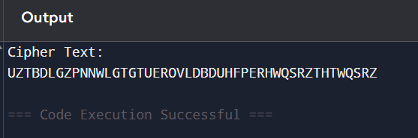
11. Key Space Analysis of Playfair Cipher
a)total Possible Keys
Arrange 25 letters in matrix
Number of ways: $25!$
Approximate value: $25!≈2^{8}3$
(b) Effective Unique Keys
Some keys give same encryption because:
- Row/column swaps don’t change result
So effective keys: $25!/(5!×5!)$
Approximate: $≈2^{8}3/2^{1}4=2^{6}9$
Code:
#include <stdio.h>
int main() {
printf("Total possible Playfair keys ≈ 2^83\n");
printf("Effective unique keys ≈ 2^69\n");
return 0;
}
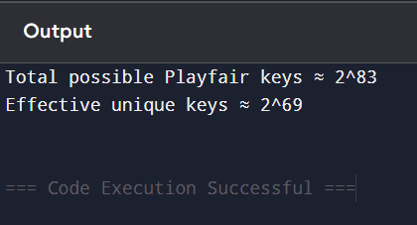

12. Hill Cipher Encryption
#include <stdio.h>
#include <ctype.h>
int main() {
int key[2][2] = {{9,4},{5,7}};
char text[] = "MEETMEATTHEUSUALPLACEATTENRATHERTHANEIGHTOCLOCK";
int i;
printf("Cipher Text: ");
for(i=0;text[i];i+=2) {
int a = text[i] - 'A';
int b = text[i+1] - 'A';
int c1 = (key[0][0]*a + key[0][1]*b) % 26;
int c2 = (key[1][0]*a + key[1][1]*b) % 26;
printf("%c%c", c1 + 'A', c2 + 'A');
}
}
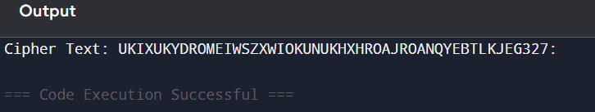
13. Demonstration of Known Plaintext Attack
#include <stdio.h>

// function to find mod inverse
int modInverse(int a) {
for(int i=1;i<26;i++)
if((a*i)%26==1)
return i;
return -1;
}

int main() {
// Example matrices (2x2)
int P[2][2] = {{7,4},{11,15}}; // Plaintext matrix
int C[2][2] = {{23,24},{25,0}}; // Ciphertext matrix

int det = (P[0][0]*P[1][1] - P[0][1]*P[1][0]) % 26;
if(det < 0) det += 26;

int invDet = modInverse(det);

// inverse of P
int Pinv[2][2];
Pinv[0][0] = (P[1][1]*invDet)%26;
Pinv[0][1] = (-P[0][1]*invDet)%26;
Pinv[1][0] = (-P[1][0]*invDet)%26;
Pinv[1][1] = (P[0][0]*invDet)%26;

// adjust negative values
for(int i=0;i<2;i++)
for(int j=0;j<2;j++)
if(Pinv[i][j]<0) Pinv[i][j]+=26;

// Find key K = C × Pinv
int K[2][2];

for(int i=0;i<2;i++) {
for(int j=0;j<2;j++) {
K[i][j] = (C[i][0]*Pinv[0][j] + C[i][1]*Pinv[1][j]) % 26;
}
}
printf("Recovered Key Matrix:\n");
printf("%d %d\n", K[0][0], K[0][1]);
printf("%d %d\n", K[1][0], K[1][1]);

return 0;
}
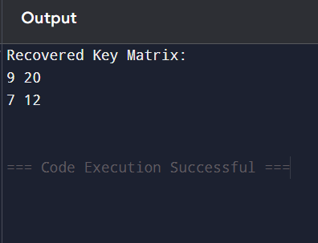

14. One-Time Pad Encryption
#include <stdio.h>

int main() {
// Part (a)
char plaintext[] = "SENDMOREMONEY";
int key1[] = {9,0,1,7,23,15,21,14,11,11,2,8,9};
char cipher[20];

int i;

printf("Part (a): Encryption\n");
printf("Plaintext : %s\n", plaintext);

for(i = 0; i < 13; i++) {
int p = plaintext[i] - 'A';
int c = (p + key1[i]) % 26;
cipher[i] = c + 'A';
}
cipher[13] = '\0';

printf("Ciphertext: %s\n\n", cipher);

// Part (b)
char new_plain[] = "CASHNOTNEEDED";
int key2[20];

printf("Part (b): Finding Key\n");
printf("Ciphertext : %s\n", cipher);
printf("Plaintext : %s\n", new_plain);

for(i = 0; i < 13; i++) {
int c = cipher[i] - 'A';
int p = new_plain[i] - 'A';
key2[i] = (c - p + 26) % 26;
}

printf("Key: ");
for(i = 0; i < 13; i++) {
printf("%d ", key2[i]);
}

return 0;
}
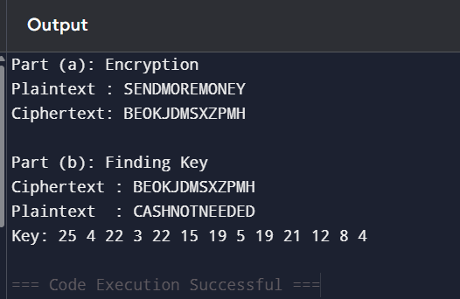
15. Frequency Attack on Additive Cipher
#include <stdio.h>
#include <string.h>
#include <ctype.h>

#define MAX 1000

// English letter frequency (approx %)
float freq[26] = {
8.2,1.5,2.8,4.3,12.7,2.2,2.0,6.1,7.0,0.2,0.8,4.0,2.4,
6.7,7.5,1.9,0.1,6.0,6.3,9.1,2.8,1.0,2.4,0.2,2.0,0.1
};

// score function
float score_text(char text[]) {
int count[26] = {0}, len = 0;

for(int i=0;text[i];i++) {
if(isalpha(text[i])) {
count[toupper(text[i]) - 'A']++;
len++;
}
}

float score = 0;
for(int i=0;i<26;i++) {
float observed = (float)count[i] / len * 100;
float diff = observed - freq[i];
score += diff * diff;
}
return score;
}

// decrypt with shift
void decrypt(char cipher[], int shift, char result[]) {
int i;
for(i=0; cipher[i]; i++) {
if(isalpha(cipher[i])) {
char c = toupper(cipher[i]);
result[i] = ((c - 'A' - shift + 26) % 26) + 'A';
} else {
result[i] = cipher[i];
}
}
result[i] = '\0';
}

int main() {
char cipher[MAX], result[MAX];
int top;

printf("Enter ciphertext: ");
scanf(" %[^\n]", cipher);

printf("Enter number of results (top N): ");
scanf("%d", &top);

float scores[26];
char results[26][MAX];

// try all shifts
for(int i=0;i<26;i++) {
decrypt(cipher, i, results[i]);
scores[i] = score_text(results[i]);
}

// print best N (lowest score = best)
for(int k=0;k<top;k++) {
int best = -1;
for(int i=0;i<26;i++) {
if(scores[i] != -1 && (best == -1 || scores[i] < scores[best])) {
best = i;
}
}

printf("\nShift %d: %s\n", best, results[best]);
scores[best] = -1; // mark as used
}

return 0;
}
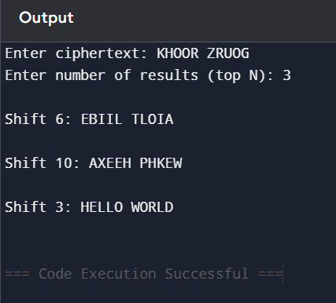
16. Monoalphabetic Frequency Attack
#include <stdio.h>
#include <string.h>
#include <ctype.h>

#define MAX 1000

// English frequency order (most → least)
char freq_order[] = "ETAOINSHRDLCUMWFGYPBVKJXQZ";

// Count frequency
void get_frequency(char text[], int freq[]) {
for(int i=0;i<26;i++) freq[i]=0;

for(int i=0;text[i];i++) {
if(isalpha(text[i])) {
freq[toupper(text[i])-'A']++;
}
}
}

// Sort letters based on frequency
void sort_letters(int freq[], char sorted[]) {
int used[26]={0};

for(int i=0;i<26;i++) {
int max=-1, idx=-1;
for(int j=0;j<26;j++) {
if(!used[j] && freq[j]>max) {
max=freq[j];
idx=j;
}
}
sorted[i] = idx + 'A';
used[idx]=1;
}
}

// Generate substitution
void generate_plain(char cipher[], char sorted[], char result[], int shift) {
for(int i=0; cipher[i]; i++) {
if(isalpha(cipher[i])) {
char c = toupper(cipher[i]);
int pos = c - 'A';

// map using shifted frequency
for(int j=0;j<26;j++) {
if(sorted[j] == c) {
result[i] = freq_order[(j+shift)%26];
break;
}
}
} else {
result[i] = cipher[i];
}
}
result[strlen(cipher)] = '\0';
}

int main() {
char cipher[MAX];
int top;

printf("Enter ciphertext: ");
scanf(" %[^\n]", cipher);

printf("Enter number of outputs (top N): ");
scanf("%d", &top);

int freq[26];
char sorted[26];
char result[MAX];

get_frequency(cipher, freq);
sort_letters(freq, sorted);

printf("\nPossible plaintexts:\n");

for(int i=0;i<top;i++) {
generate_plain(cipher, sorted, result, i);
printf("\nOption %d:\n%s\n", i+1, result);
}

return 0;
}
